**Milestone Report:**

Problem statement: Classification is used across all fields and we use it every day in everything we do. If we can formulate a classification model to accurately predict and classify an animal, then those similar models can be utilized in other classification tasks as well such as in the implementation of medical diagnoses, in the filtering of spam from ham, in learning associations between product purchases, in determining loan disbursement criteria, and also in recognizing images and speech. In this capstone 2 project, animal classification can be helpful in identifying attributes associated with different animals in order to understand the animal kingdom better. It can be used to classify venomous vs non-venomous animals for public safety when outdoors. It can also be useful in identifying attributes associated with the endangerment of animals. Finally, it can be useful in classifying wild animals from domestic animals.

Clients: Clients that would be interested in this classification problem would be scientists, zoologists, researchers, archeologists, park rangers, paleontologists, wildlife conservationists, microbiologists, veterinarians and educators. Also, since this classification problem can be applied to many other classification problems, as specified above, there are many other clients that could also benefit from the classification models implemented in this project.

**Data:** The dataset for this project consists of 101 animals from a zoo from the UCI machine learning repository (Dua, D. and Graff, C. (2019). The acknowledgment for the data source is: UCI Machine Learning Repository, [http://archive.ics.uci.edu/ml],( Irvine, CA: University of California, School of Information and Computer Science)[1]. There are 99 unique animal names with frog repeated twice since one frog is classified as venomous and the other is not. Since the UCI researcher included human in the row of animal names, that row was dropped as part of data cleaning. There were 18 columns in one dataset with 16 of those 18 boolean column values assigned to different animal attributes. Both datasets included the Class_Type column. There were 7 different Class Types which included: Mammal, Bird, Reptile, Fish, Amphibian, Bug and Invertebrate. The two datasets were checked for missing values and merged together on their common column. The common column was also the target variable or response predicted from the classification of the 16 different Boolean valued attributes. Animal name columns were removed before beginning sci-kit learn since variables need to, of course, be numerical for sci-kit learn machine learning models. The variable “Number of Animal Species In Class” , although numerical, was also dropped since it made the machine learning models too easy.

Exploratory Data Analysis: The correlation heatmap found the following trends:

**1.)High correlation between teeth and backbone which is due to "Teeth being formed from neural tube, the embryonic tissue that becomes the brain and spinal cord.[2]"**

**2.) High correlation between aquatic and fins which, of course, makes sense.**

**3.)High correlation between tail and backbone which also makes sense**

**4.)Low correlation between domestic animals and predators which also makes sense**

**5.)There is high correlation between breathing and animals with hair and strong negative correlation between not breathing and fins**

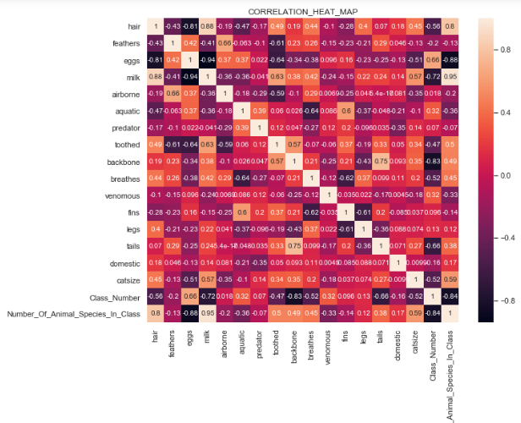

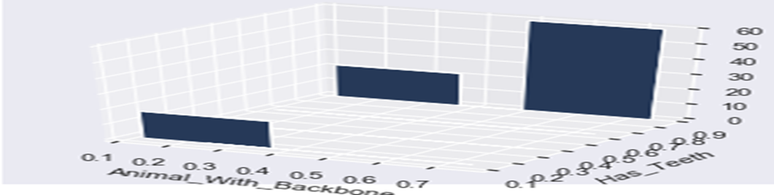

Visualization utilizing a heat map shows how the correlation between teeth and backbone is one of the highest correlations at close to 60% and the 3d bar plot above shows why it is not higher than 60%. Specifically, it shows that there are a small number of animals without a backbone that have teeth even though the majority of animals with a backbone have teeth.

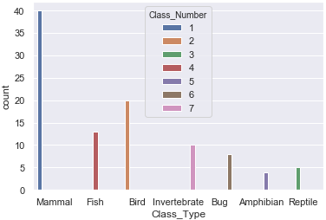

**The majority of animals fall in class number 1 (mammals ) which includes: aardvarks, antelopes, bears, and boars-just to name a few. The visualization above shows how the different classes are distributed.**

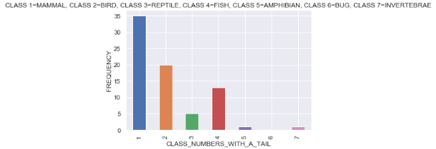

**What this shows is that 75% of the animals in the dataset have tails and 50% of those 75% are mammals(Class 1). It is important to note, however, that not all mammals have tails. NO bugs(Class 6) have a tail and very few amphibians and invertebrates(Class 5 & 7) have a tail. Finally, Birds, Reptiles and Fish(Classes 2, 3 & 4) ALL have tails. Since only one class of animals, bugs, which consists of only 8 out of the total 100 animals, do not have tails, it is plausible that tails may NOT be the strongest feature in our classification algorithms.**

**Other Visualizations and Trends seen:**

* **Pie chart showed the highest percentage of animals without a backbone are invertebrates which validates the heatmap correlation finding that if there was a high correlation between animals having a backbone and a tail that there might also be a lot of animals without a backbone that do not have a tail.**
* **3D scatterplot showed that class 1 animals(mammals) have a backbone and also showed that the majority of animals in the dataset have a backbone and thus backbones may not be the strongest feature for animal classification. Finally, this 3D plot shows that many animals in classes 6&7 do not have a backbone which makes sense since those classes are invertebrates and bugs.**
* **Seaborn scatterplot showed that the majority of predators are not airborne.**
* **Seaborn scatterplot showed that domestic animals fall in the classes of 1, 2, 4 and 6 which corresponds to: mammals, birds, fish and bugs respectively but that all the classes contain animals that are not domestic. This may be why there is a low correlation between the feature domestic and other attributes. This may also mean it is not the strongest feature for animal classification. Finally, this shows the only domestic animals that are aquatic are class 4(fish) which makes sense.**
* **Seaborn scatterplot showed 6 out of the 7 classes include aquatic animals, with the exception of bugs, and that 5 out of the 7 classes have animals that are not aquatic. This visualization, along with the low correlation with other features on the heatmap, shows that aquatic may also not be the strongest feature in our machine learning classification models. Finally, this shows that finned animals belong to classes 1 & 2(mammals and fish).**
* **Seaborn bar plot showed there were no venomous animals in class 1 & class 2(mammals and fish). It also showed that the majority of venomous animals are in classes 3, 6 and 7(reptiles, bugs and invertebrates). Overall, venomous animals were seen to be pretty evenly distributed among the different animal classes and thus may also not be the strongest predictor in animal classification.**

## **Hypothesis Testing #1:**

### null hypothesis: animals that can breathe that have fins - animals that can't breathe that have fins = 0

### alt hypothesis: animals that can breathe that have fins - animals that can't breathe that have fins != 0[¶](http://localhost:8888/notebooks/Desktop/cap_stone_project_2/Zoo%20Classification.ipynb#alt-hypothesis:--animals-that-can-breathe-that-have-fins---animals-that-can't-breathe-that-have-fins-!=-0)

Conclusion**:**

**Since the p-value is less than 0.05, we reject the null hypothesis and conclude there is a statistical difference between animals that are domestic that are predators and animals that are not domestic that are predators. This statistical conclusion makes sense since our correlation heatmap showed a very low correlation between domestic animals and animals that are predators. In addition, the attribute domestic does not appear to be a strongly weighted feature in animal classification. In conclusion, our hypothesis testings between attributes statistically agrees with our previous data explorations and visualizations.**

**Hypothesis Testing #2:**

**null hypothesis: animals that are domestic that are predators - animals that are not domestic that are predators = 0**

**alt hypothesis: animals that are domestic that are predators - animals that are not domestic that are predators != 0**

**Conclusion:**

**Since the p-value is less than 0.05, we reject the null hypothesis and conclude there is a statistical difference between animals that are domestic that are predators and animals that are not domestic that are predators. This statistical conclusion makes sense since our correlation heatmap showed a very low correlation between domestic animals and animals that are predators. In addition, the attribute domestic does not appear to be a strongly weighted feature in animal classification.**

Acknowledgments:

[1] UCI machine learning repository(Dua, D. and Graff, C. (2019). UCI Machine Learning Repository, [http://archive.ics.uci.edu/ml]. Irvine, CA: University of California, School of Information and Computer Science)